MTH 325 Fall 2024 – Exam 1 Solutions

**Skill 1:**

**(CORE) I can outline a proof by mathematical induction.**

Consider the following proposition: For every integer $n≥5$, $4n<2^{n}$.

1. State the value of *n* that corresponds to the base case, then prove that the base case holds.
2. Clearly state the inductive hypothesis. Your answer should be phrased as a complete sentence. (No explanation is required here; simply state the inductive hypothesis.)
3. Clearly state what you would need to prove, after assuming the inductive hypothesis. Your answer should be phrased as a complete sentence. (You do not need to give a completed proof the statement; simply state what you would need to prove.)

Solutions

1. The value of *n* for the base case is *n* = 5. In this case, the left side of the inequality is 20 and the right side is 32. Since 20 < 32, the base case holds.
2. Assume for some positive integer *k* that $4k<2^{k}.$
3. We want to prove that $4\left(k+1\right)<2^{k+1}$.

**Skill 2:**

**(CORE) I can outline a proof using direct, contrapositive, and indirect approaches.**

Consider the following proposition: For all integers *n*, if $n^{5}$ is even then *n* is even.

1. Clearly state what you would assume and what you would need to prove, if you were to prove this statement with a *direct proof*. (No further explanation is necessary.)
2. Clearly state what you would assume and what you would need to prove, if you were to prove this statement with a *proof by contrapositive*. (No further explanation is necessary.)
3. Clearly state all assumptions you would make, if you were to prove this statement with a *proof by contradiction* (also known as an *indirect proof*). (No further explanation is necessary.)

Solutions

1. Assume that $n^{5}$ is even. Then prove that *n* is even.
2. Assume that *n* is odd, Then prove that $n^{5}$ is odd.
3. Assume that $n^{5}$ is even and that n is odd.

**Skill 3**

**(CORE) I can represent a graph in different ways, determine information (degree, degree sequence, paths of given length, etc.) about a graph using different representations, and give examples of graphs with specified properties.**

Consider the graph *G* given by this Python dictionary:

{0: [4, 7], 1: [2, 3, 4, 5, 6], 2: [1, 6], 3: [1, 7], 4: [0, 1, 6],

5: [1, 6, 7], 6: [1, 2, 4, 5], 7: [0, 3, 5]}

1. In the table below, state the degree of each vertex. You don’t need to explain your answers here, just make sure they are right.
2. Find the number of edges in the graph. Show your work or otherwise explain your reasoning.
3. Give an example of a cycle of length 4. If no such cycle exists, say so and explain how you know.
4. Give an example of a walk in this graph, that is not a trail. Explain in one sentence why your example fits the description. If no such walk exists, say so and explain how you know.
5. Give an example of a path of length 10 in this graph. If no such path exists, say so and explain how you know.

Solutions

1. Completed table below (which we can get by finding the length of each list in the dictionary):

|  |  |  |  |  |  |  |  |  |
| --- | --- | --- | --- | --- | --- | --- | --- | --- |
| *v* | 0 | 1 | 2 | 3 | 4 | 5 | 6 | 7 |
| Deg(*v*) | 2 | 5 | 2 | 2 | 3 | 3 | 4 | 3 |

1. One way is to draw the graph and manually count edges. Another is to use the Handshake Lemma. From the table, the degree sum is 2+5+2+2+3+3+4+3 = 24. This is twice the number of edges, so the number of edges is 12.
2. One such cycle is 1, 2, 6, 5, 1. This is a walk because each pair of consecutive vertices is adjacent as seen in the dictionary. It starts and ends at 1, so it’s a closed walk. And no vertices or edges are repeated, so it’s a cycle. And there’s 4 edges in all, so it’s a cycle of length 4.
3. A walk that is not a trail would be a walk (consecutive vertices are adjacent) but there is a repeated edge. There are lots of examples but the easiest is just going out one edge and then backtracking, for example: 1, 2, 1.
4. This graph has no path of length 10. A path cannot repeat a vertex, so a path of length 10 would have to include 9 different vertices. But there are only 8 in this graph.

**Skill 4**

**I can determine whether a graph has an Euler trail or Euler circuit, and whether a graph has a Hamiltonian path or circuit.**

Consider the graph *G* shown below:

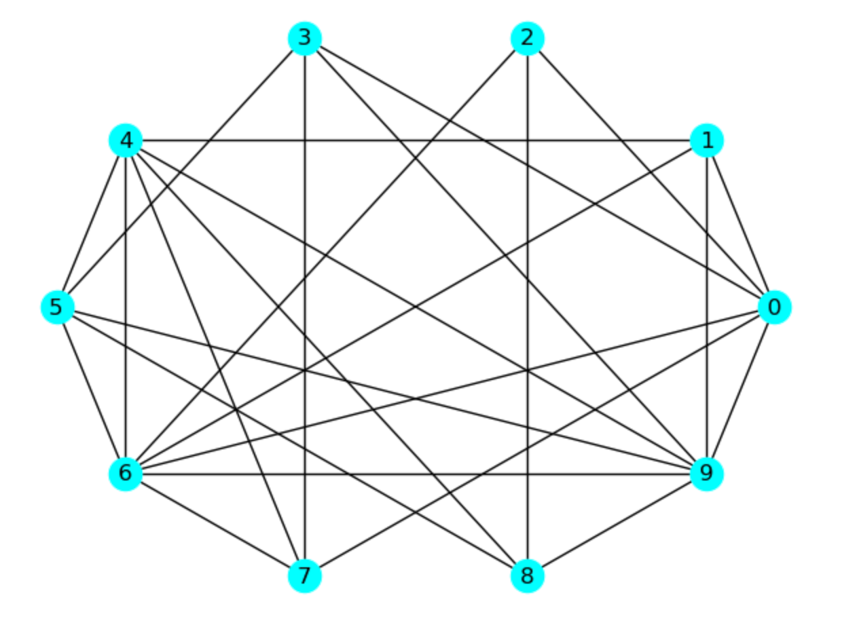

1. Determine whether this graph has an Euler trail, and explain how you know.
2. Determine whether this graph has an Euler circuit, and explain how you know.
3. Determine whether this graph has a Hamilton path, and explain how you know.
4. Determine whether this graph has a Hamilton circuit, and explain how you know.

Solutions:

1. There is no Euler trail in this graph, because not all of the vertices have an even degree – for example deg(2) = 3.
2. There is no Euler circuit in this graph, because there are more than two vertices with an even degree – vertices 2, 5, 6, and 9 all have odd degree.
3. There *is* a Hamilton path in this graph. One example is 0, 1, 4, 5, 6, 7, 3, 9, 8, 2.
4. There *is* a Hamilton circuit as well, for example 0, 1, 4, 5, 6, 7, 3, 9, 8, 2, 0. (Just take the Hamilton path and close the circuit.)